|  |  |  |
| --- | --- | --- |
|  | **JSPM’s**  **RAJARSHI SHAHU COLLEGE OF ENGINEERING**  **TATHAWADE, PUNE-33**  **(An Autonomous Institute Affiliated to SavitribaiPhule Pune University,Pune)** |  |

**Department of Information Technology**

**Innovation by Faculties in Teaching Learning**

1. **Statement of Clear Goal, Use of appropriate methods, Significance of results, Effective presentation**

**Name of the Course:** Operating System

**Name of the Faculty:** Dr. Gitnajali .S. Mate

**Name of the Innovative Method used:** Youtube Video

**Name of the topic:** Interprocess Communication using FIFO

**Statement of Clear Goal**:

The goal of YouTube channel is to provide a comprehensive and easy-to-understand interprocess communication using FIFO and .Through the channel covers fundamental concept of FIFO creation and communication between two processes. The objective is to create a space for practical insights, enhancing their understanding and application of FIFO in both academic and professional contexts with visual contents

**Significance of result:**

"The implementation of FIFO (First-In-First-Out) interprocess communication (IPC) in an operating system serves as an important demonstration of how processes can communicate with one another in a structured, orderly manner. By utilizing FIFO queues, processes can exchange data where the first message sent is the first message received, ensuring efficient data management and synchronization.

The significance of showcasing this implementation on a YouTube channel is twofold:

1. **Educational Value:** It helps viewers understand a key mechanism in interprocess communication, which is foundational for system programming and OS design. The FIFO method demonstrates how to manage data flow between processes, which is essential for tasks like handling input/output operations, managing resources, or running parallel processes.
2. **Real-World Applications:** This video emphasize practical implementation FIFO IPC is used in modern operating systems, embedded systems, and real-time applications. This help viewers relevance of FIFO in managing communication between processes in real-world software development, from system-level applications to network protocols.

**Effective Presentation (Screenshot):**

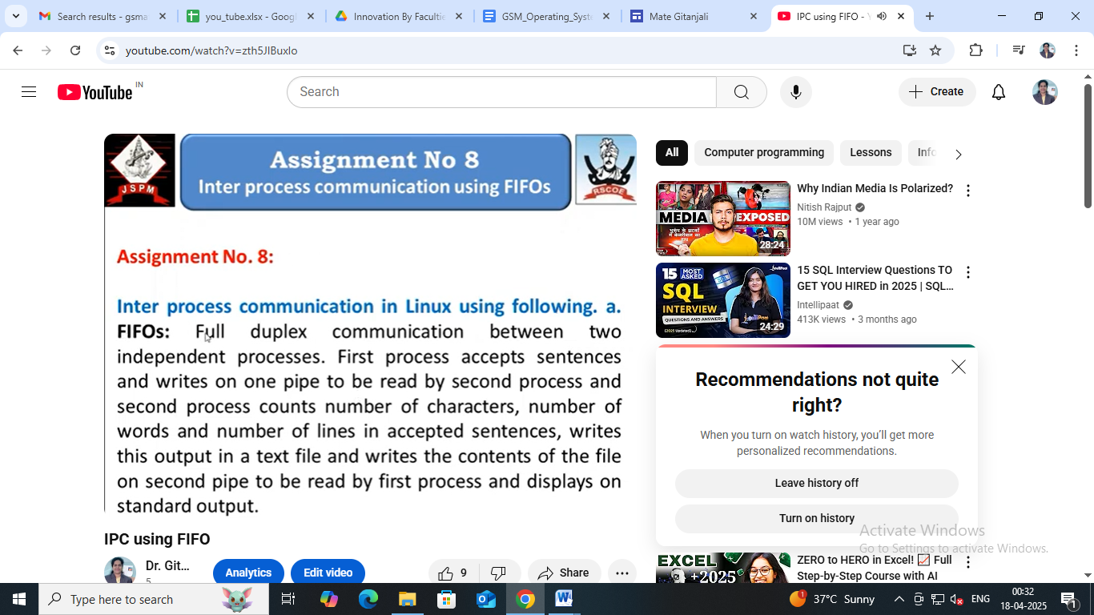

**B. Availability of work related to Innovation by Faculty in Teaching and Learning is on Institute website.**

**URL of the availability of the work on website**

[**https://sites.google.com/jspmrscoe.edu.in/mategitanjali/home**](https://sites.google.com/jspmrscoe.edu.in/mategitanjali/home)

[**https://www.jspmrscoe.edu.in/information-technology/innovation-practices**](https://www.jspmrscoe.edu.in/information-technology/innovation-practices)

1. **Peer Review and Critique (Feedback):** Comments of videos.

[**https://github.com/jspmIt/GSM**](https://github.com/jspmIt/GSM)

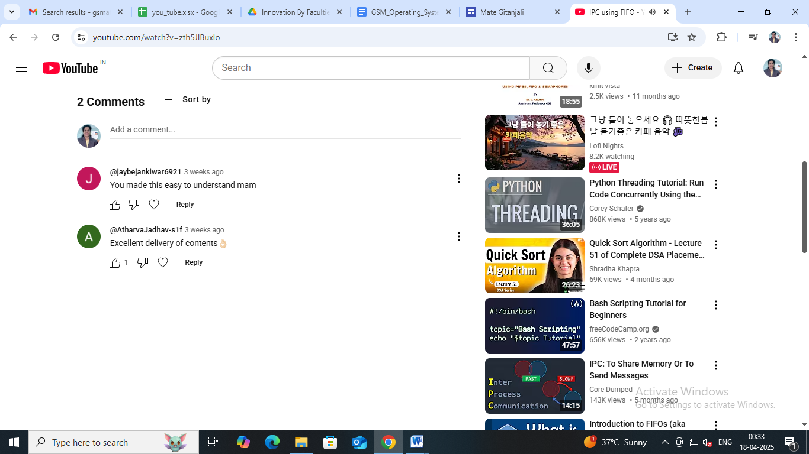

**D: Reproducibility and Reusability by other scholars for further development**

* **Views**, **likes**, **comments**, and **shares: The users watch the videos and do comments aas weel as shares with others**
* Students used it for better understanding and shares with their friends

|  |  |  |  |
| --- | --- | --- | --- |
| **Sr.No** | **Innovation Used by** | **Details of User** | **Purpose of**  **Reproducibility and Reusability** |
| **1.** | **YouTube Video** | **Dr. D.H. Patil** | Used the content to demonstrate the practical for second year students |
|  |  | **Dr. J.M. Sarwade** | Used the content to demonstrate the practical for third year students |

**Course Co-ordinator Module Co-ordinator HOD**

Dr. G.S. Mate Dr. G.S. Mate Dr. Nihar M. Ranjan